|  |  |
| --- | --- |
| ***Advances In Additive Manufacturing***  <https://aiam.sciencescall.org/> |  |

**Title: AIAM Conference Paper Template (14 Times New Roman)**

First Author*1, Second Author2 and Third Author3 (11 Times New Roman)

1Authors’ Laboratory, Institute, Adress, Country, e-mail (10 Times New Roman),

2 Authors’ Laboratory, Institute, Adress, Country, e-mail (10 Times New Roman),

3Authors’ Laboratory, Institute, Adress, Country, e-mail (10 Times New Roman),

*Corresponding author E-mail: [correspondingauthorname@aaa.bbb](mailto:correspondingauthorname@aaa.bbb)

**Abstract**

This is the template and instructions for papers. Authors are advised to read the paper guidelines carefully and follow them strictly.

The paper should start with an abstract of a minimum of 200 words and a maximum of 250 words, which summarizes the objectives, and conclusions of the paper. The abstract should not include references, figures, or tables. The abstract is very important as it will initiate and give an overview of the whole work.

**Keywords**: Indicate no more than **5 keywords** written in lowercase, separated by semicolons: Additive manufacturing; 3D printer; modelling; materials; AIAM’2023.

1. **Introduction**

The paper can be written in French or in English. All communications are peer-reviewed. Only those having received a favorable opinion from the reviewers will be accepted for presentation at the AIAM’2023 conference.

Authors are requested to submit their manuscripts in PDF format online at the conference website.

<https://aiam.sciencescall.org/>

The number of pages of the paper **must not exceed 4 pages in total.**

1. **Presentation of the manuscript**

The manuscript must be typed in a single line, in a double column, in Times New Roman font, size 10, with 2. cm margins. It must include, in order, an abstract, a maximum of five keywords, the text (including figures and tables) and references. All pages should be numbered.

**2.1. Title of chapters**

The chapter titles are numbered as follows:

1;1.1;1.1. 1;….and in bold Times New Roman.

**2.2. Figures and Tables**

Figures and tables will be numbered in increasing Arabic numbers as they appear in the text. Figures, with their legends and tables, with their titles, must be integrated into the body of the text. All illustrations (Figure 1 and Table 1) must be referred to in the text. We will write figure 1 / table 1 in full in the text.

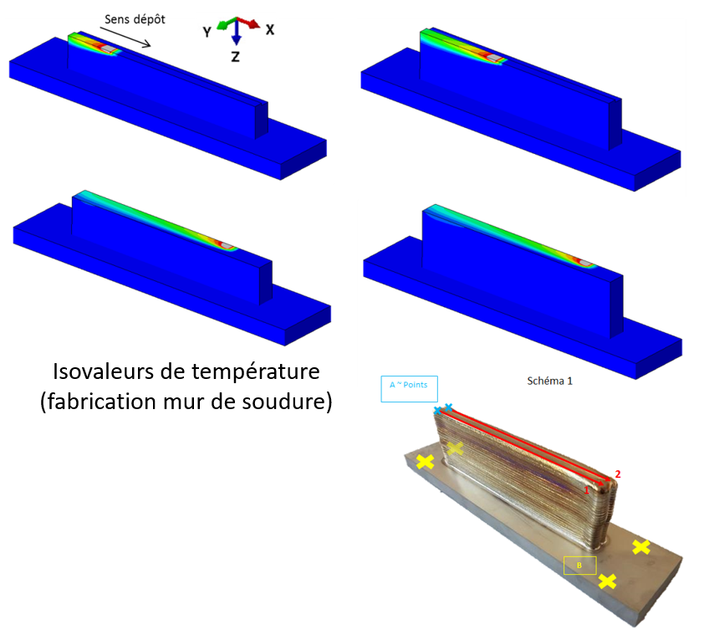

***Figure 1.*** *Example of figure*

***Table 1.*** *Style of table*

|  |  |  |
| --- | --- | --- |
| **merging lines** | **merging columns** | |
| ***Subtitle*** | ***Subtitle*** |
| data | data |  |

**2.3. Equations**

Equations must be entered carefully. Those referred to in the text [in the form: equation (1), for example], should be numbered in Arabic numbers in parentheses at the edge of the right margin.

                                                                 

Never put punctuation at the end of equations. Particular attention must be paid to clearly differentiate the number zero (0) and the letter (O), the number one (1) and letter l, and the Roman letter v and the Greek letter nu (υ).

1. **Conclusion**

The paper must end with a conclusion that presents the main results of the work.

**References**

References should be inserted at the end of the document, numbered in alphabetical order by author. Two examples of references are proposed: an article [1] and a book [2].

1. *LIU, Zhiyuan, ZHAO, Dandan, WANG, Pei, et al. Additive manufacturing of metals: Microstructure evolution and multistage control. Journal of Materials Science & Technology, 2022, vol. 100, p. 224-236.*
2. *GIBSON, Ian, ROSEN, David W., STUCKER, Brent, et al. Additive manufacturing technologies. Cham, Switzerland: Springer, 2021.*